Customer Behaviour Analysis : Business Problem & Insights Report
Business Problem
Retail businesses collect large amounts of customer transaction data every day. However, raw data alone does not provide meaningful information for decision-making. Companies need to understand how customers behave, what products they prefer, and how different customer segments contribute to overall sales.
Without proper analysis, businesses face several challenges:
- Inability to identify high-value customers
- Difficulty understanding purchasing patterns
- Ineffective marketing campaigns
- Poor inventory planning
- Missed opportunities for increasing sales and customer retention
The objective of this project is to analyze customer shopping behaviour and generate actionable insights that can support business growth and improve customer engagement.
Business Objectives
The main objectives of this analysis are:
- Understand customer purchasing behaviour.
- Identify spending patterns among different customer groups.
- Determine the most popular product categories.
- Analyze the relationship between customer demographics and purchasing decisions.
- Support data-driven marketing and sales strategies.
- Develop an interactive dashboard for business stakeholders.

Analytical Approach
Data Preparation
The dataset was cleaned and prepared by:
- Removing duplicate records
- Handling missing values
- Correcting data inconsistencies
- Standardizing data formats
Exploratory Data Analysis
The analysis focused on:
- Customer demographics
- Purchase frequency
- Spending behavior
- Product category performance
- Revenue distribution
SQL Analysis
SQL queries were used to:
- Aggregate sales metrics
- Analyze customer segments
- Calculate category-wise performance
- Generate business KPIs
Dashboard Development
An interactive Power BI dashboard was developed to visualize:
- Customer distribution
- Product category sales
- Spending patterns
- Key performance indicators

Dashboard
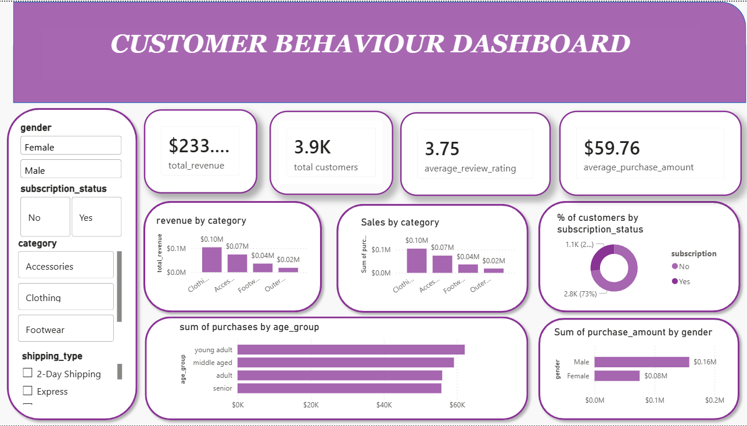

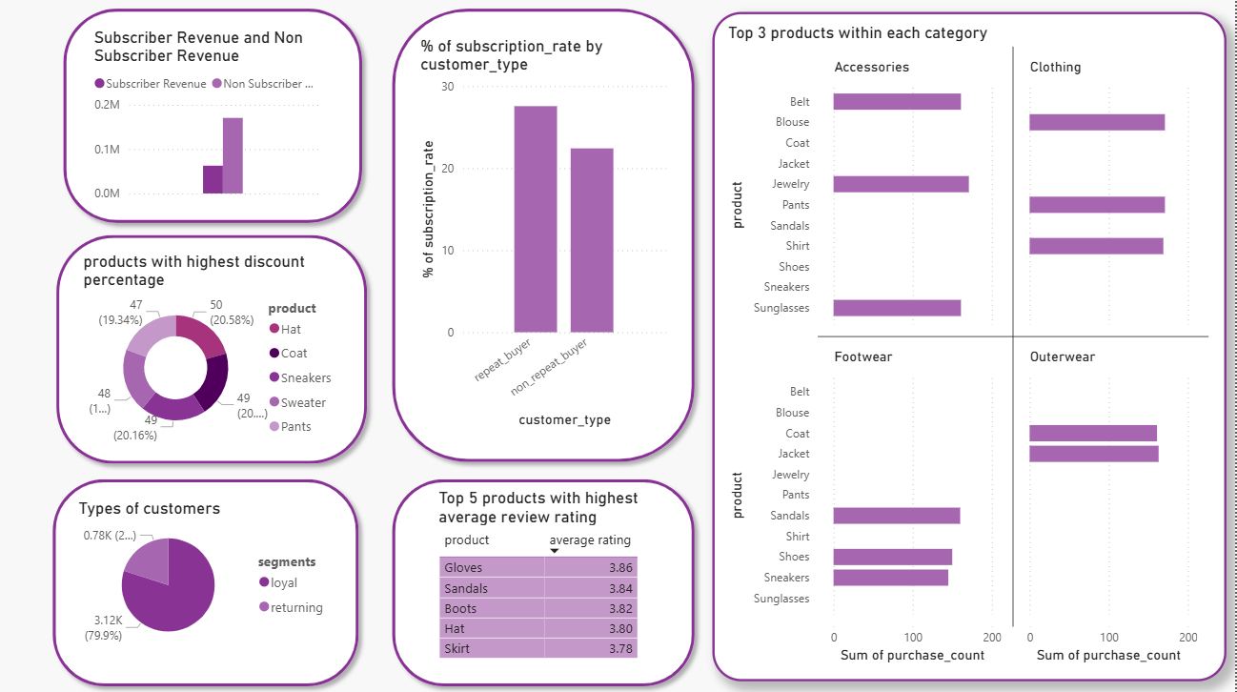

Key Business Insights
Insight 1: Customer Spending Behavior
Customers demonstrate different spending habits based on demographic and behavioral factors. Some customer groups contribute significantly more revenue than others.
Business Value
Businesses can target high-spending customer segments with personalized promotions and loyalty programs.
Insight 2: Product Category Performance
Certain product categories consistently attract higher customer demand and generate greater revenue.
Business Value
Organizations can focus inventory planning and promotional activities on top-performing categories.
Insight 3: Customer Segmentation
The analysis reveals distinct customer groups based on purchasing behavior and spending levels.
Business Value
Segment-specific marketing strategies can improve customer retention and increase conversion rates.
Insight 4: Revenue Contribution
A smaller percentage of customers contributes a substantial portion of total revenue.
Business Value
Retaining these high-value customers can significantly impact business profitability.
Insight 5: Purchasing Trends
Customer purchasing activity exhibits patterns that can be used to forecast demand and optimize business operations.
Business Value
Better demand forecasting helps reduce inventory costs and improve product availability.

Recommendations
Based on the analysis, the following recommendations are suggested:
Marketing
- Implement personalized marketing campaigns.
- Create loyalty programs for high-value customers.
- Target customer segments with customized offers.
Sales
- Promote high-performing product categories.
- Use cross-selling and upselling strategies.
- Monitor customer purchasing trends regularly.
Operations
- Improve inventory planning based on demand patterns.
- Track key performance indicators through dashboards.
- Use data-driven insights for strategic decision-making.
Business Impact
This analysis helps businesses:
- Better understand customer behavior
- Improve customer retention
- Increase sales opportunities
- Optimize inventory management
- Enhance decision-making through data analytics
Conclusion
Customer behavior analysis transforms transaction data into meaningful business insights. By understanding customer preferences, spending habits, and purchasing trends, businesses can make informed decisions that improve operational efficiency, customer satisfaction, and overall profitability.

